UML HW 2

Andres Namm

Table of Contents

Homework Description 2

Sequence Diagrams 4

State Machines 8

# Homework Description

# 

**Description of System Behavior**

The users specify the system behavior as follows:

1. A new customer can register to join as a member. They need to input personal information to the Member object. After storing the information, Member will send the successful signal to the member.

2. When a member wants to buy film tickets, they may enter the membership number or send the membership number from the RFID sensor to the Management object. Then Management will ask the member to input password. There is a button named “Unmask Password”. If it is clicked, display the password again with the dots replaced by actual characters. After receiving the password from the member, Management will send a signal to fetch data from Member for verification. If Management found that the member information is not correct, Management will display an error message to the member. If the member information is correct, Management will send a signal to the Purchase object for fetching the film information. After receiving the information, Management will display the available films and seats to the member. The member selects the film and seats and sends the signal back to Management. Then Management will calculate the price and let the member to choose the payment methods. The member sends a signal to Management after they settle the payment. Management will send the purchase information to Purchase. After saving the information, Purchase will send the saved signal to Management. The data fetching process and the calculation may take some time.

3. At the end of each month, an Award object will be created by Management. Award will send a signal to fetch the purchase records from Purchase. After sorting the purchase records, Award will send the top 3 member information to Management. When Management receives the information, it sends another signal to fetch the member data from Member. Then Management will show a dialog box to the manager. When the manager clicks the “Confirm” button within half an hour, Management will receive a confirm signal and then send a signal to Member asking them to send congratulation

2

email message to the selected members. If the “Confirm” button is not clicked within half an hour, Management will send a cancel signal to Member.

**Assignment Deliverables**

Please conduct dynamic modeling on the above specification. Hint:

1. Construct sequence diagram(s) according to the description of system behavior.

2. This assignment is independent of Assignment 1 even though we use the same example to make it interesting. Hence, you should only make use of the details specified in this assignment but not the information from Assignment 1.

3. To ease your workload, you are not required to prepare use case descriptions or class diagram for this assignment.

4. To ease your workload, you do not need to consider alternative courses of events that are not specified in the assignment.

5. Construct state machines for the objects, which are underlined in the above section:

(a) Member

(b) Management

(c) Purchase

(d) Award.

6. You may add actors to the sequence diagrams as you see fit, but you are not allowed to add new objects.

Remind yourself to be consistent with variables.

# Sequence Diagrams

## Member Account Creation

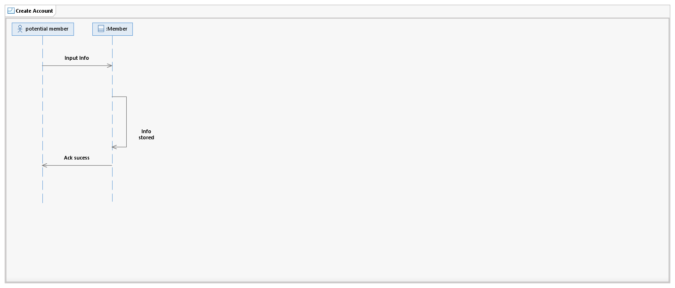

## BuyFilmTicket

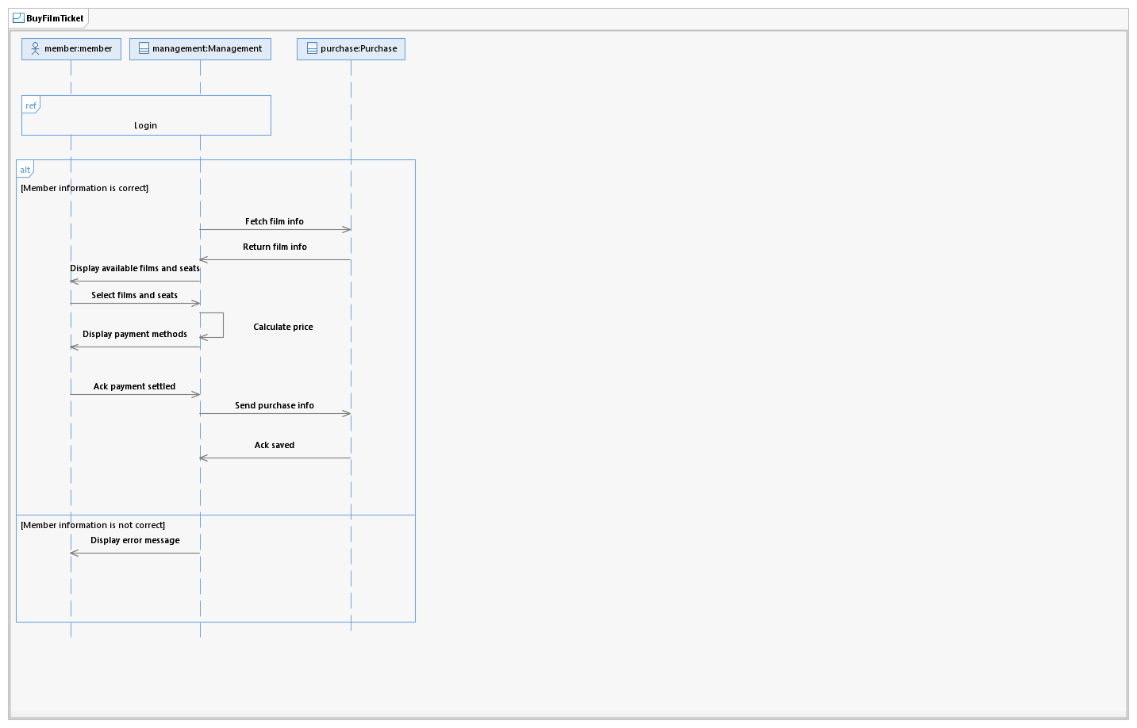

## Reference Login

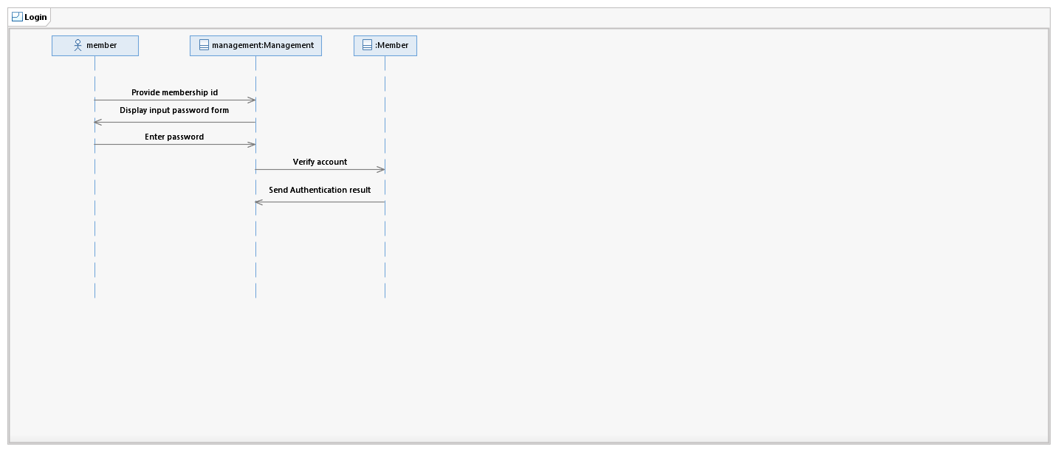

## Monthly Awards

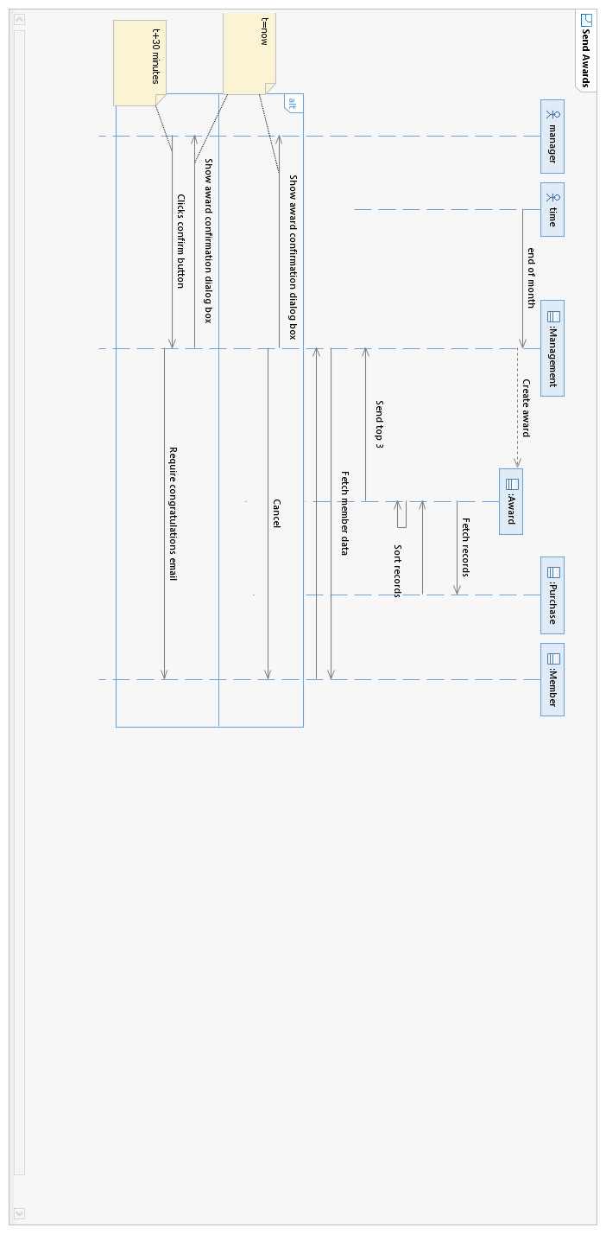

# State Machines

## Purchase

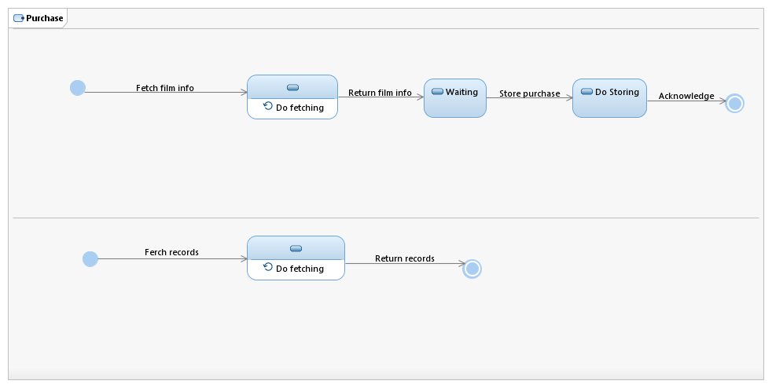

## Member

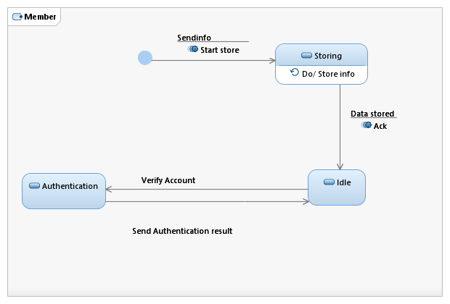

## Management

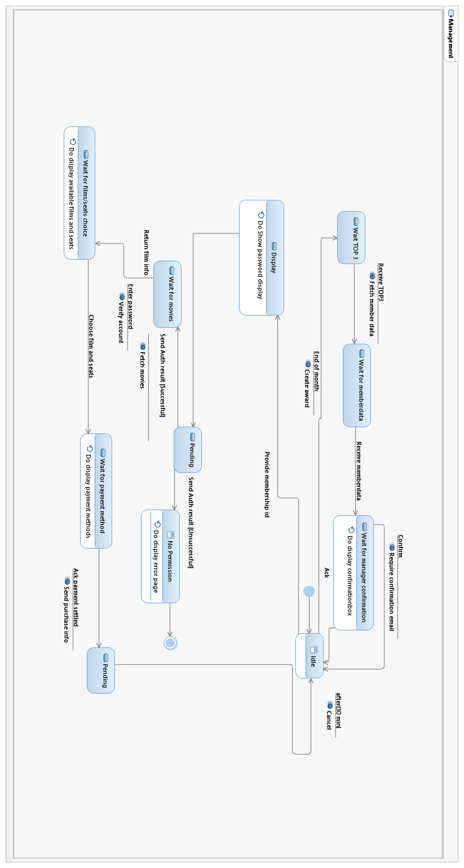

## Award

